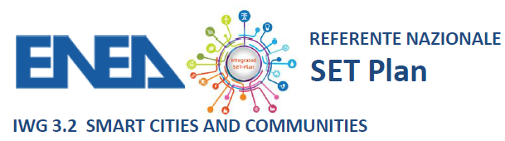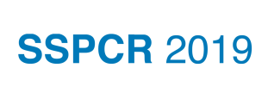
ENEA e EIP-SCC nel contesto del
3rd INTERNATIONAL CONFERENCE ON
“SMART AND SUSTAINABLE PLANNING FOR CITIES AND REGIONS – SSPCR 2019”

propone un incontro tra le Municipalità italiane Lighthouse , Follower Cities, città UIA e città partner della EIP-SCC al fine di attivare percorsi di qualificazione per i Positive Energy District e diffondere la Smart Cities Guidance Package.

On 11th December Italian smart cities qualified as Lighthouse cities / Follower cities within European Smart Cities & Communities projects or involved in Urban Innovative Actions (UIA) or members of EIP-SCC will meet to discuss about further projects within the new Horizon Europe framework.This event aims in particular to share experiences and expectation on how further develop Positive Energy Districts projects and implementing the Smart Cities Guidance Package.
Invited municipalities include, among others, Milano, Bolzano, Trento, Parma, Padova, Ravenna, Livorno, Portici, Roma, Firenze, Lecce, Prato, Bassano del Grappa, Venezia, Torino, Bologna, Latina, Bergamo, Brescia.
For further information please see the final agenda or contact Paola Clerici Maestosi (coordinator of EERA Joint Programme on Smart Cities an vice-chair JPI Urban Europe) or Simona Costa (action cluster leader EIP-SCC).
The event will be held in Italian; by invitation only.

Bolzano, 11 dicembre
NOI Techpark, Bolzano – via A. Volta 13°

DRAFT AGENDA
09.00-11.00 |  | Plenary SSPCR 2019
11.00-11.30 |  | Coffe break
11.30-13.00 | 11.30-11.40 | Goal of the meeting: introducono Paola Clerici Maestosi e Simona Costa
 | 11.40-12.00 | SET Plan, Mission Innovation e PNIEC Georg Houben DG Energy, Marcello Capra Italian Ministry of Economic Development
 | 12.00-13.00 | Presentations of Italian cities involved in Smart cities projects
13.00-14.00 |  | Lunch Break
14.00- 16.00 | 14.00-14.30 | Positive Energy Districts in Horizon 2020
 | 14.30-15.00 | Positive Energy Districts in EIP: tools and Smart Cities Guidance Package
 | 15.00-15.45 | Road Map
 | 15.45-16.00 | Conclusions

