Title of the Paper [Style: Title Paper SSPCR]
Name Surname, Name Surname and Name Surname [Style: Author Names SSPCR]
Abstract [Style: Abstract & Acknowledgements Heading SSPCR]
When preparing the paper, it is recommended to write directly into this template and to replace the model text (please use always the correct style as indicated in the style sheet). Please do not insert any blank lines between the different sections of the paper (line spaces are predefined in the style sheet). – Each paper must include an abstract of 200 to 400 words. You can reduce the text already used when you answered the SSPCR 2019 call for abstracts. Text must be in Arial 9 pt. The abstract must be written in American English, the same language as the main text of the paper. Please do not repeat the abstract in the main text of the paper, e.g. as part of the introduction. The heading Abstract should be aligned left, in Arial 10 bold. [Style: Abstract & Acknowledgements Text SSPCR]
Keywords: give at least three and maximum five keywords separated by semicolons; you can reuse the keywords already used when you answered the SSPCR 2019 call for abstracts; do not end the keyword list with a full stop [Style: Keywords SSPCR]

Format [Style: HEADING 1 SSPCR]
Each paper must be submitted as a doc. or docx. file.
Apart from headings, author information and captions, the text should be fully justified. The font for the main body of the text [Style: Normal] should be Arial 10 pt.
Only block paragraphs should be used; do not indent the first line of paragraphs.

General Instructions
Length
The paper should be in the range of six to eight pages (excluding abstract, appendices and references).
Structure
Please use this or a similar structure: Abstract / Introduction / Method / Results / Discussion / Conclusion
Naming convention
Please use this structure: Abstract number_Surname first author (e.g. 3960_Smith)
Page Numbering
Please do not include page numbers in your paper. The definitive page numbering of papers published in the proceedings will be decided by the organizing committee of SSPCR.
Line Numbering
Please keep on the “line numbering option” (https://support.office.com/en-gb/article/Add-or-remove-line-numbers-b67cd35e-422c-42eb-adc9-256ca9802e22)

Headings/Level 1 Headings [Style: Heading 1 SSPCR]
All headings, including the main title, should be capitalized according to the following rules: use upper case for the first word as well as for content words and lower case for function words (e.g. The Title of the Paper). Headings are aligned left. Type level 1 headings in Arial 12 pt bold. Use Arabic Numerals for each heading and subheading (apart from paper title, abstract, acknowledgements, and appendices); do not use a full stop after the last numeral (e.g. 4, 4.1, 4.1.1). Do not end a title or heading with a full stop.

Headings/Level 2 Headings [Style: Heading 2 SSPCR]
The format for level 2 headings is basically the same as for level 1 headings. Level 2 headings must be numbered accordingly (e.g. 1.1, 1.2). Use headings and subheadings up to a maximum of three levels.

Headings/Level 2 Headings
Please note that there must always be at least two level 2 and level 3 headings if you need to use these in your paper (e.g. at least 4.1 and 4.2 ).

Headings/Level 3 Headings [Style: Heading 3 SSPCR]
The format for level 3 headings is the same as for level 2 headings, except that the font is Arial 10 pt.

References in the text
All references within the text should be placed in parentheses containing the author's surname followed by the date of publication (Verlinde 2009). If the sentence already includes the author's name, then it is only necessary to put the date in parentheses: Verlinde (2009). When citing several authors, use a semicolon to separate the references: (Verlinde 2009; Atkins and Rundell 2008). For citing page numbers use the following format: (Rundell 2012: 49) or (Rundell 2012: 49-51). When the reference has more than three authors, only cite the name of the first author followed by et al. (Rundell et al. 2012)

Citations
Short citations up to 1-2 lines are embedded in the main body of the text using quotation marks: “Metalexicography is a broad discipline […]” (Rundell 2012: 49). Longer citations should form a separate paragraph; use Arial 9 pt and spaces of 6 pt before and 6 pt after the citation. Do not use quotation marks; the reference must be put at the end of the citation without any punctuation mark following it:
Metalexicography is a broad discipline, taking in subjects such as dictionary criticism, dictionary typology, the history of lexicography, and the description of dictionary microstructures. These are all valid areas of study. The question for practising lexicographers is how far [my italics] any of this impacts on how they do their jobs or helps them to produce better dictionaries. (Rundell 2012: 49) [Style: Citation SSPCR]
Use double quotation marks for short citations but also for terms and expressions that are used in a special sense (occasional meaning), e.g. a “harmless drudgery”. For quotations within quotations use single quotation marks, e.g. “[...] ‘harmless drudgery’ […]”. Omissions should be signalled with three dots within square brackets: […]. Square brackets are also used to signal remarks by the author (see citation example above: [my italics]).

Emphasis and Foreign Words
Use italics for foreign language and emphasis. Please refrain from the use of FULL CAPS, bold type and underlining.

Figures and Tables

Figures
All figures should be centred and clearly readable [Style for figures: Figure holder SSPCR]. Colour figures are allowed. Figures should be supplied in a clean and high quality format, using, if possible, a resolution of a minimum of 300 dpi. Figures should be numbered and each figure has to be referred to in the main text (see Fig. 1). Number figures consecutively (Fig. 1, Fig. 2, etc.). Place captions in Arial 9 pt below the table, aligned left, starting with Fig. x. Spacing of captions should be set at 6 pt before and 6 pt after. Figure and caption should always appear together on the same page.

Example:
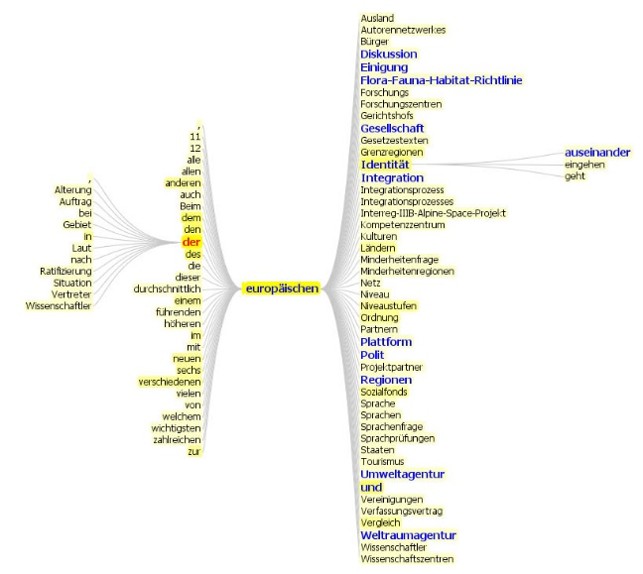
Fig. 1 Caption [Style: Caption Table & Figure SSPCR].

Tables
All tables should be in B&W, having the same width of the text (100%) and clearly readable [Style for tables: Table SSPCR]. Tables should be numbered and each table has to be referred to in the main text (see Table 1). Number tables consecutively (Table 1, Table 2, etc.). Place captions in Arial 9 pt above the table, aligned left, starting with Table x. Spacing of captions should be set at 6 pt before and 6 pt after. Table and caption should always appear together on the same page.

Example:
Table 1 Caption [Style: Caption Table & Figure SSPCR].
Region | South
City | Medium size
District | Central

Footnotes
Footnotes are indicated in the text by a number in superscript. Please note that superscript numerals follow punctuation marks.

Lists
Items in lists should be preceded by a dot; the dots are not intended; the text after the dot is hanging at 1.1 cm; otherwise the same rules apply as in the formatting of examples; e.g.:
- planning tools [Style: List SSPCR]

Consent to publish
Authors of contributions to SSPCR will be asked to sign consent to publish for publication immediately after the notification of acceptation. We remind you that it is in the author’s responsibility to obtain any permission required for the use of material owned by others.
Acknowledgements (optional) [Style: Abstract & Acknowledgements Heading SSPCR]
Place all acknowledgements (including those concerning research grants and funding) in a separate section after the conclusion section, before the Reference section. The format used for the acknowledgements is the same as for the abstract [Style: Abstract & Acknowledgements Text SSPCR].

Appendix (optional) [Style: Heading 1 SSPCR]
Place all appendices in a separate section before the references. The format and rules are the same as for the main body of the text [Style: Normal]. Text should be Arial 10 pt. Tables and/or figures should be numbered separately and each has to be referred to in the appendix text (See Table 1, Table 2 and Table 3).If you use more than one Appendix multiply the section using the following heading names: Appendix 1, Appendix 2, etc.

References
Bibliographical references are mandatory (at least 10 ) and should be listed in alphabetical order at the end of the paper. The title of the section, References, should be a level 1 heading. The first line of each bibliographical reference is not indented whereas the rest of the entry should be indented by 0.50 cm.
The following examples of references illustrate the basic format required for conference proceedings, books, journal papers, and chapters of books respectively. When referring to online sources please do not forget to indicate the date on which you have accessed it at the end of the reference.

Krupnick, A., Burtraw, D., & Markandya, A. (2000). The ancillary benefits and costs of climate change mitigation: A conceptual framework. In Ancillary Benefits and Costs of Greenhouse Gas Mitigation: Proceedings of IPCC Workshop, 27–29 March 2000. Paris: OECD.
Sorrell, S., O’Malley, E., Schleich, J., & Scott, S. (2004). The economics of energy efficiency. Northampton: Edward Elgar.
Kim, C. W., Phipps, T. T., & Anselin, L. (2003). Measuring the benefits of air quality improvement: A spatial hedonic approach. Journal of Environmental Economics and Management, 45(1), 24–39.
Cantarelli, C. C., & Flyvbjerg, B. (2015). Decision making and major transport infrastructure projects: The role of project ownership. In R. Hickman, M. Givoni, D. Bonilla, & D. Banister (Eds.), Handbook on transport and development (pp. 243–258). Northampton: Edward Elgar.
Macmillan English Dictionary Online. http://www.macmillandictionary.com. Accessed May 13, 2018.

Your affiliation details, address, email@xxxxx.xx (email is mandatory only for corresponding author).
Your affiliation details, address, email@xxxxx.xx (email is mandatory only for corresponding author).
Your affiliation details, address, email@xxxxx.xx (email is mandatory only for corresponding author).
They should be in Arial 9 pt, and appear at the bottom of the same page as their corresponding number. [Style: Footnote Text SSPCR].

